CENWP-OD-B 18 June 2023

MEMORANDUM FOR THE RECORD

SUBJECT: 23BON029 MFR WA Shore UMTJ Rest Box Pacific Lamprey Mortalities

On 18 June, Bonneville Fisheries discovered one adult Pacific Lamprey mortality in Rest Box 2 (UMTJ RB2) of the Washington Shore Lamprey Passage System. The fish was scanned for PIT tags, inspected, and returned to the river.

- Species – Pacific Lamprey (Entosphenus tridentatus)
- Origin – Unknown
- Length – 63.5 cm
- D-G. Marks and tags, Marks and Injuries found on carcass, Cause and Time of Death, Future and Preventative Measures – None or not applicable.
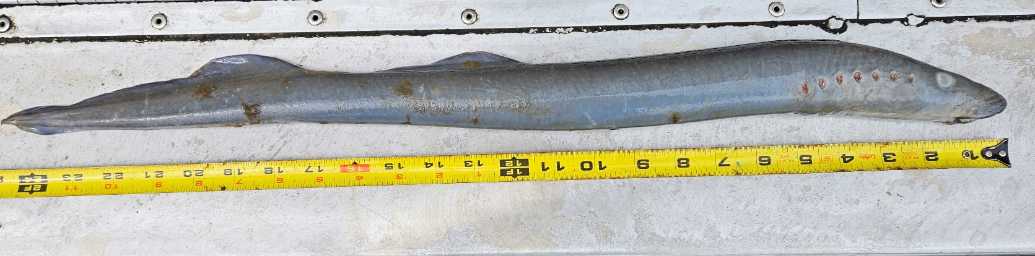

On 18 June, Bonneville Fisheries discovered one adult Pacific Lamprey mortality in Rest Box 5 of the Cascade Island Lamprey Passage System. The fish was scanned for PIT tags, inspected, and returned to the river.

- Species – Pacific Lamprey (Entosphenus tridentatus)
- Origin – Unknown
- Length – 67.3 cm
D-G. Marks and tags, Marks and Injuries found on carcass, Cause and Time of Death, Future and Preventative Measures – None or not applicable.

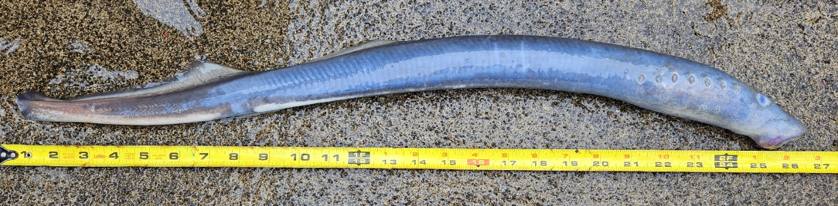

Sincerely,
Bonneville Project Fisheries

